MINUTES FOR DISTRICT 41 MEETING HELD JANUARY 15, 2015
NOTE: Mailing Address - District 41 Treas. P.O. Box 7226, Villa Park, IL 60181
NOTE: Mailing Address - District 41 Answering Service, P.O. Box 6365, Villa Park, IL 60181-5318
NOTE: NIA web site: www.aa-nia.org

PRESENT AT MEETING:
Tina A., Mary D., Alicia E., Michael F., Jason H., Michael K., Walt K., Linda L., Jean M., Pam M., Tom Ma, Tom Mo, John S. and Faith W.
Meeting opened at 7:00 pm with a Quiet Time, Serenity Prayer, GSR Preamble, 1st Tradition and 1st Concept for World Service. Basket passed for the 7th tradition.
Jason H. chaired the meeting.

INTRODUCTIONS:
New GSRs – None.
Visitors – Tina A., Perry (DCM District 15), Dave, Mike, Faith W., Dan L. (Area 20 Corrections Chair), Sue and Andrew
Anniversaries – Tina A. (2 yrs.) and Jason H. (4 yrs.)
Birthdays – Michael
Announcements: None.
NEW BUSINESS: Jason H. recommended attendance at Winter Committee Meeting.

Proposal for 2015 District budget will be presented at the next District Meeting on February 19, 2015.

OLD BUSINESS: Jason H. reported that Mike G. is in the process of finding a high school as a venue for the Area’s Summer Assembly on June 13, 2015.
DuPage County Open Registration Chair, Mary D. and Greeting Chair, Faith W., presented flyers and reported on progress.

OFFICERS REPORTS:
Secretary: (Tom M.) December 2014 Minutes were approved.
Treasurer: (Linda L.) Reviewed month’s contributions. Ending balance is $3,346.42.
DCM: (Jason H.) See written report below.

District 41 DCM Report 1/15/15:

District 41 GSR’s & Committee Members:

Happy New Year District 41! I hope everyone had a great holiday! The chair people we elected last month to help with the Dupage Open and the Area Assembly in June will update us on their progress. We are still exploring facilities in District 41 to host the Area Assembly. Our Area Corrections Chair is also having a Corrections Workshop on February 28^{th.} As soon as he has a flyer for this I will email it out to everyone. Coming up on the 24th of this month is the Winter Committee meeting in La Fox. There will also be a “General Service Orientation” at this meeting. New GSR’s and committee members are encouraged to attend to meet your fellow service committee members and share ideas.

Mike O., our former D41 secretary, has volunteered to chair the Newsletter committee.

Thank all of you for your dedicated service to A.A.!

Yours,

Jason H.

Other items:
- All committee members are encouraged to attend the NIA Winter Committee Meeting on January 24th in La Fox.
- Please remember: All committee expenses must be accompanied by a receipt to receive reimbursement.
Alt. DCM: (John S.) Presented NIA calendar for 2015. Reviewed upcoming events. Brought flyers for distribution.
ANSWERING SERVICE: (Maggie A.) Absent. See written report below.
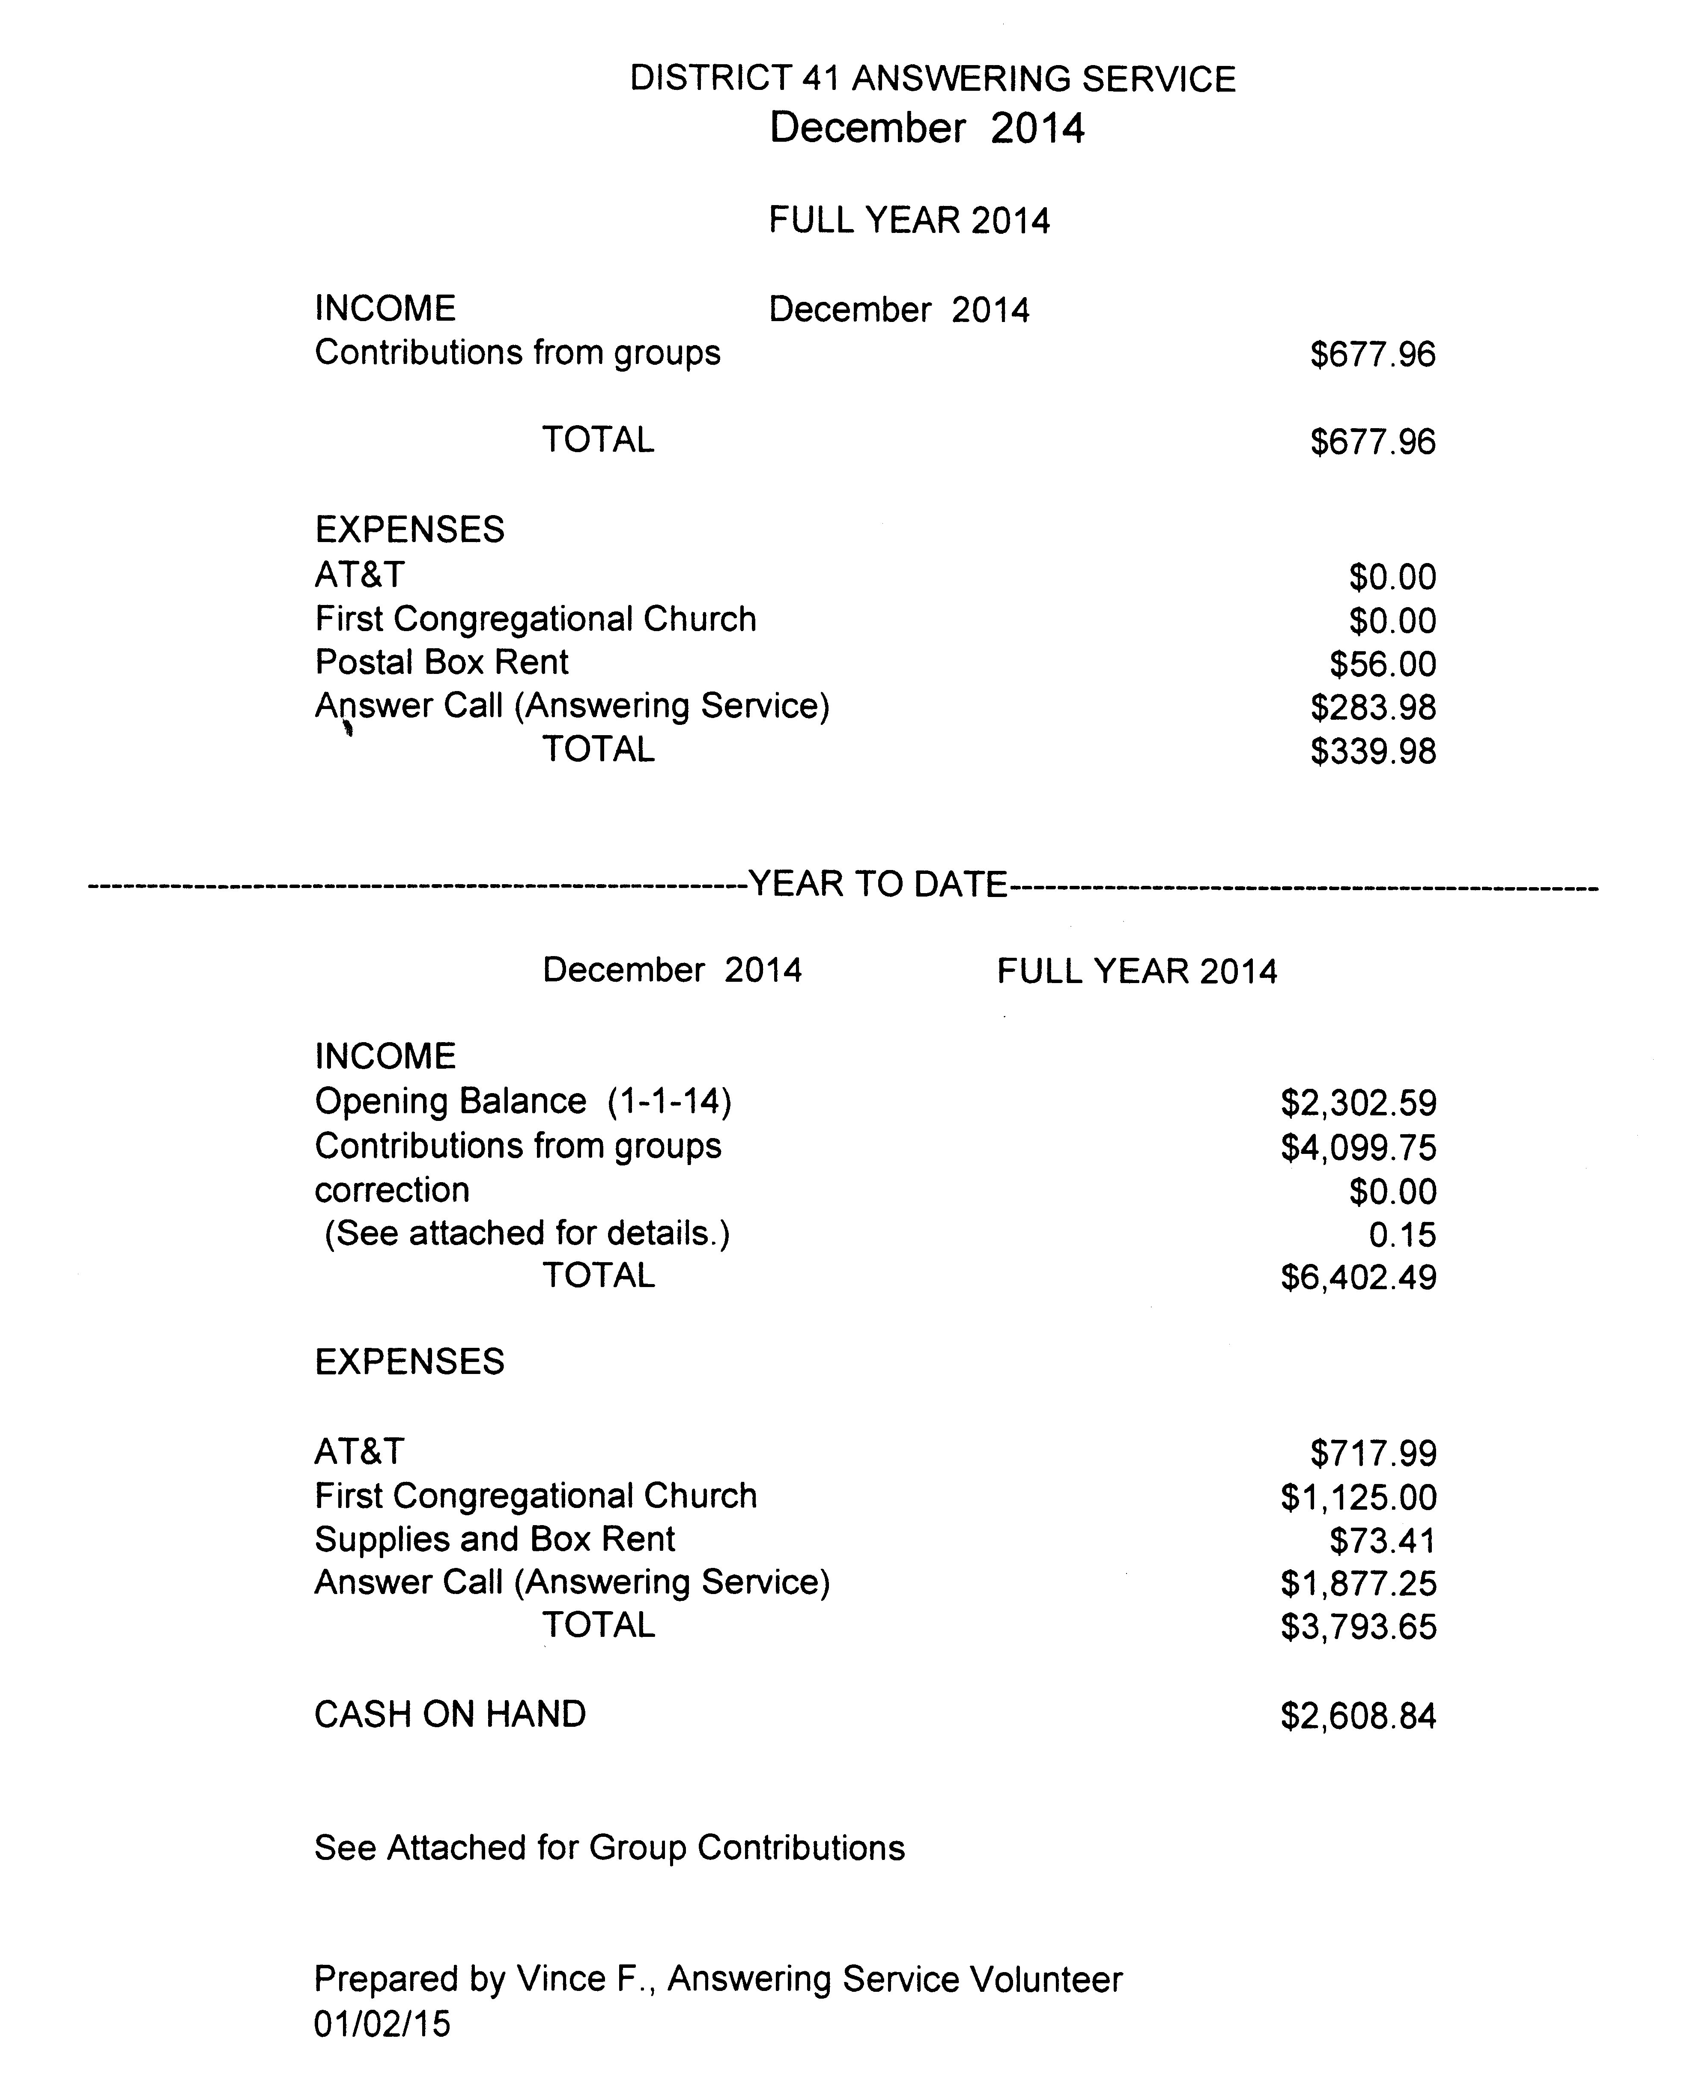
ARCHIVES: (Open)
BTG: (Tom M) At recent Area Assembly in LaFox, it was decided to combine Corrections, Treatment, CPC and PI under one umbrella to be coordinated by Rich H. of Area 20. Will be going to Elmhurst Hospital to meet the Director of the Bridge Group and provide information on Bridging the Gap program. Reported on a motion at LaFox to add the annual BTG Workshop Weekend to the Primary Purpose Register.
CPC/PI: (Walt K.) Requested sabbatical due to family illness. Reported on Willowbrook Wellness Program. Inquired about the discussion of space on AA brochures for contact info.
CORRECTIONS: (Todd G.) Absent.
ALT. CORRECTIONS: (Tina A.) Reports she will attend the Area Conference.

GRAPEVINE: (Open)
ALT. GRAPEVINE: (Susan H.) Absent.
LIAISON/ANONA EAST: (Maggie A.) Absent.
LCM: (Ray W.) Absent.
NEWSLETTER: (Open) Mike O. elected as Chair.
SPECIAL NEEDS: (Susan H.) Absent.
TREATMENT: (Mike F.) Delivered Big Books to Elmhurst Hospital. Will order more pamphlets. Working on CIC chairs and speakers.
WEBTECH: (Jeane M.) Reported 414 new visitors in December. There were 813 return visitors for a total of 1,227 hits. Set up and discussed features of Survey Monkey for events.
WORKSHOPS: (Lee K.) Absent.

Closed with Lord’s Prayer.

If you are a District 41 member and have not attended a district meeting within the last six months, chances are your name will be removed from the mailing list.

The next meeting will be held Thursday, February 19, 2015 @ 7:00 P.M. Anona Center East.

